'charset' => 'utf8',

],

1. That is it. Now you have two database connections and you can use them with DAO and Query Builder, as follows:

$rows1 = Yii::$app->db->createCommand($sql)->queryAll();

$rows2 = Yii::$app->db2->createCommand($sql)->queryAll();

1. Now, if we need to use Active Record models, we first need to create the Post and Comment models with Gii. You can select an appropriate connection for each model. Set the db2 for database connection ID when you create the Comment model, as shown in the following screenshot:

5. Now you can use the Comment model as usual and create controllers/ DbController.php, as follows:

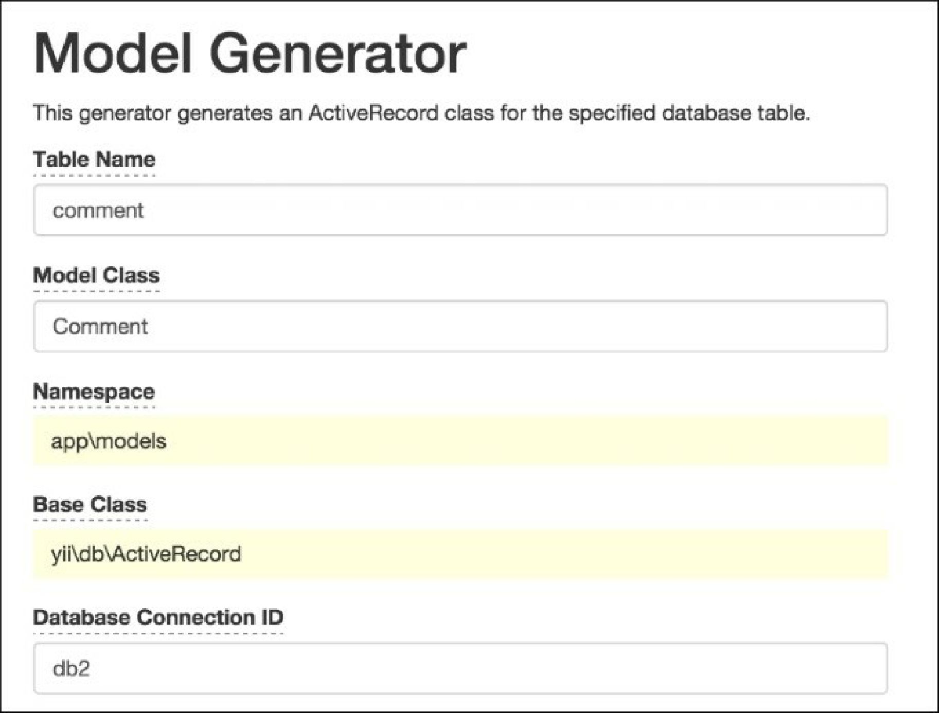

<?php

namespace app\controllers;

use app\models\Post; use app\models\Comment;